ANNEX C

Drawing showing overtake manoeuvre

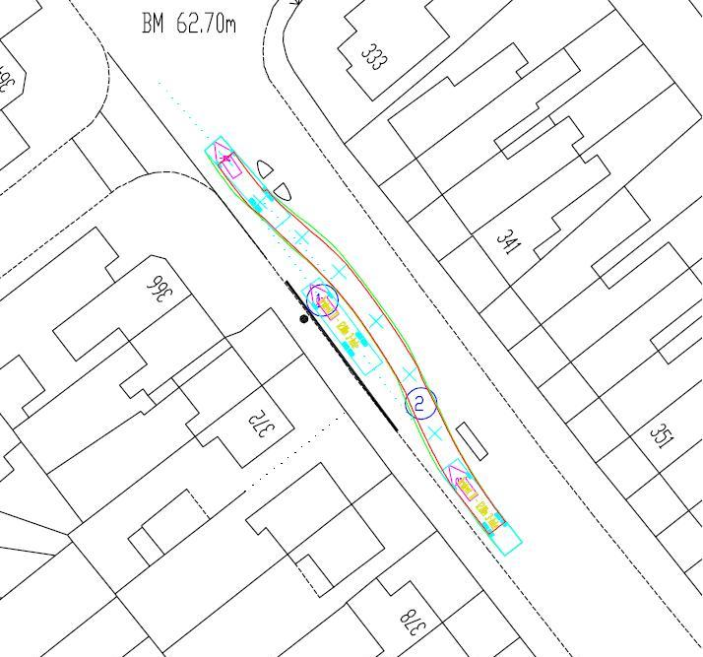
Bus stop clearway
Bus stop flag and pole
The diagram above has been generated using a CAD package. It shows that a 12 metre bus is able to overtake another stationary 12 metre bus at the proposed new bus stop location.

Modelling has been carried out for ‘MAN.220’ and ‘VOVLO B10BLE’ buses, the largest types in operation on this corridor.

